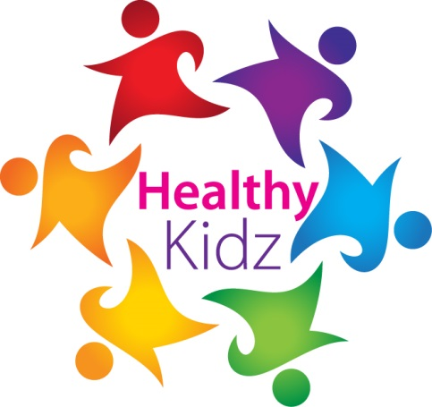
INSERT SCHOOL LOGO

HEALTHY KIDZ MOST ACTIVE PUPIL award

This certificate is presented for outstanding activity BOTH INSIDE AND OUTSIDESCHOOL during MARCH 2017

This month ______________________ recorded ___________ points on the healthy kidz app.
Well done
Signed _____________________
INSERT SCHOOL LOGO

SILVER award

This certificate is presented TO ____________________________
for outstanding activity to good health during your healthy kidz lessons.
CONRATULATIONS ON THE IMPROVEMENTS MADE
Paul Carvill
(DIRECTOR OF COACHING)
INSERT SCHOOL LOGO

GOLD award

This certificate is presented TO ____________________________
for outstanding activity to good health during your healthy kidz lessons.
CONRATULATIONS ON THE IMPROVEMENTS MADE
Paul Carvill
(DIRECTOR OF COACHING)

