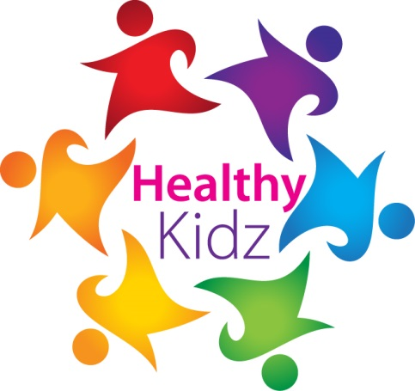
INSERT SCHOOL LOGO

HEALTHY KIDZ MOST ACTIVE CLASS award

This certificate is presented for outstanding activity DURING THE GOLDEN MILE SESSIONS IN SEPTEMBER 2017.

This month MR KEATING’S CLASS WERE THE BEST CLASS AT THE GOLDEN MILE IN THE HEALTHY KIDZ PROGRAMME.
Well done
Signed _____________________
INSERT SCHOOL LOGO

SILVER award

This certificate is presented TO ____________________________
for outstanding activity to good health during your healthy kidz lessons.
CONRATULATIONS ON THE IMPROVEMENTS MADE
Paul Carvill
(DIRECTOR OF COACHING)
INSERT SCHOOL LOGO

GOLD award

This certificate is presented TO ____________________________
for outstanding activity to good health during your healthy kidz lessons.
CONRATULATIONS ON THE IMPROVEMENTS MADE
Paul Carvill
(DIRECTOR OF COACHING)

