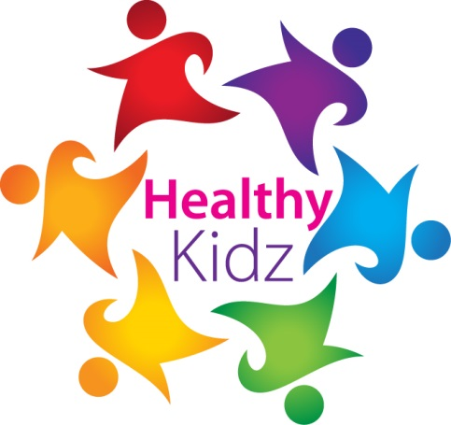
INSERT SCHOOL LOGO

HEALTHY KIDZ award

This certificate is presented for outstanding activity DURING THE HEALTHY KIDZ PROGRAMME DURING 2018 / 2019.

ThiS YEAR MR KEATING’S CLASS SUCCESSFULLY COMPLETED THE HEALTHY KIDZ PROGRAMME.
Well done
Signed _____________________
INSERT SCHOOL LOGO

SILVER award

This certificate is presented TO ____________________________
for outstanding activity to good health during your healthy kidz lessons.
CONRATULATIONS ON THE IMPROVEMENTS MADE
Paul Carvill
(DIRECTOR OF COACHING)
INSERT SCHOOL LOGO

GOLD award

This certificate is presented TO ____________________________
for outstanding activity to good health during your healthy kidz lessons.
CONRATULATIONS ON THE IMPROVEMENTS MADE
Paul Carvill
(DIRECTOR OF COACHING)

