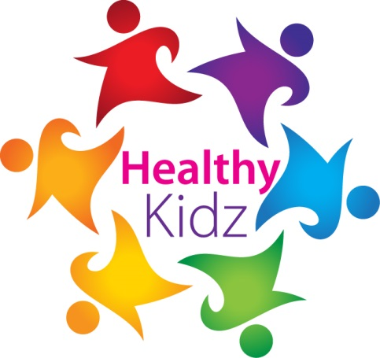
INSERT SCHOOL LOGO

HEALTHY KIDZ MOST ACTIVE PUPIL award

This certificate is presented for outstanding activity BOTH INSIDE AND OUTSIDESCHOOL during NOVEMBER 2017

This month ______________________ recorded ___________ points on the healthy kidz app.
Well done
Signed _____________________

