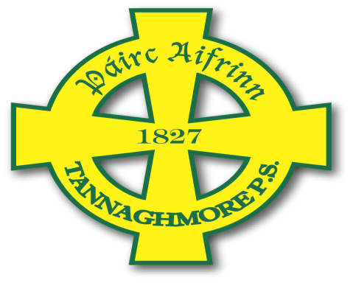
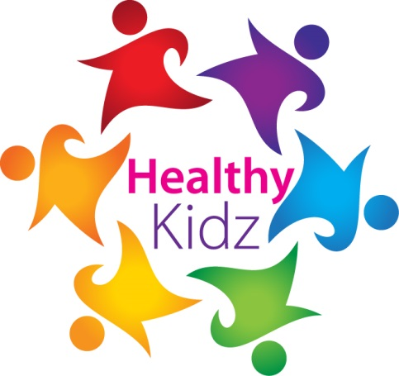

HEALTHY KIDZ MOST ACTIVE award

This certificate is presented for outstanding activity OUTSIDE SCHOOL during FEBRUARY 2017.

This month ______________________ recorded ___________ points on the healthy kidz app.
Well done
Signed _____________________

