The BIG WORKOUT DAY

Golden Mile: constant JOG / WALK for 2min30seconds around entire field
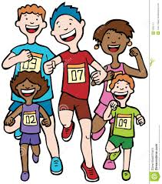
Bench Strength Exercises:
- Arm dips
- Step ups
- Press ups
- Sit ups
- Burpees
- 20-second plank
- Split-feet jumps
- Alternate knee thrusts
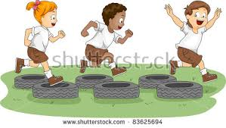
Tyre Run
Rock / Paper / Scissors
Partner work
Balance boards
Army crawl
Monkey catchers
Bear crawl – fill the bucket!
Tug of War / Carry the can

The BIG WORKOUT DAY

Dear Parents,
The Healthy Kidz programme has been a fantastic innovation into school this year, providing a fun and effective fitness-improvement programme for pupils during curriculum time and after school. We have been so impressed by the improvement in the fitness levels of the participants that we want to extend the programme in the next school year.
To help facilitate this, your child will be taking part in a unique fundraising “Big Workout Day” with their class. This is a fun-filled, station-based activity day which, perhaps, will test their endurance levels!
All money raised will be directed into school funds and further PE Physical Literacy programmes for all pupils. All pupils who raise money will have the chance to win spot prizes and the pupil who raises the most money will win an iPad mini!
Your support is very much appreciated and we wish all pupils the very best of luck in their “Big Workout Day!”
Many thanks as always for your support.

P Carville
PE Coordinator Healthy Kidz co-ordinator Principal

The BIG WORKOUT DAY

Dear Parents,
The Healthy Kidz programme has been a fantastic innovation into school this year, providing a fun and effective fitness-improvement programme for pupils during curriculum time and after school. We have been so impressed by the improvement in the fitness levels of the participants that we want to extend the programme in the next school year.
To help facilitate this, your child will be taking part in a unique fundraising “Big Workout Day” with their class. This is a fun-filled, station-based activity day which, perhaps, will test their endurance levels!
All money raised will be directed into school funds and further PE Physical Literacy programmes for all pupils. All pupils who raise money will have the chance to win spot prizes and the pupil who raises the most money will win an iPad mini!
Your support is very much appreciated and we wish all pupils the very best of luck in their “Big Workout Day!”
Many thanks as always for your support.

P Carville
PE Coordinator Healthy Kidz co-ordinator Principal

We are going to have a fun day. How much money can you raise for the school????
iPAD MINI FOR THE HIGHEST COLLECTOR!
Name of sponsor | Amount
 | PRIZE DRAW FOR ALL WHO RAISE MONEY!
 | EVERYONE CAN WEAR THEIR FOOTBALL SKIPS FOR THE DAY!

