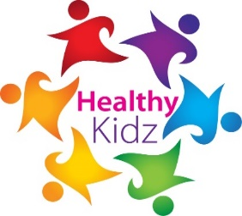
Celebration Colour Run
Friday 16th March, Portadown Peoples Park

Dear Parent / Guardian,

Healthy Kidz in partnership with Armagh, Banbridge and Craigavon Council are very pleased to invite your child to our ‘2018 Celebration Colour Run’.

This day is in place to celebrate the great work of a representation of pupils in our primary schools who have already been doing their highly unique, universal and all-inclusive Healthy Kidz sessions this academic year.

The celebration will entail hundreds of pupils, from many different schools, undertaking their ‘Golden Mile’ run in Portadown People’s Park on Friday 16th March between 10 am – 12 pm. Each child will also participate in a series of ‘work-out’ stations.

Within the ‘Golden Mile’, the pupils will be covered in our safe ‘colours’, which is a child-friendly, non-staining, non-allergy dust.

This will not only look amazing, but will be great fun and camaraderie for all involved. We do ask that the pupils can do this run in their ‘older clothes’, and bring a change for their return journey to school. Water will be supplied on the day for everyone.

This is an exciting day, with many media outlets and local personalities planning to be there. Q Radio are confirmed to be supplying the music for the event.

With your confirmed attendance, we hope for everyone to enjoy a fantastic celebration of the Healthy Kidz programme and very much look forward to seeing you on the day.

Yours in Health,

Paul Carvill

